

**TDS 3751 – Social Media Computing**

**Assignment 1 – Social Media Campaign & Metrics**

**Retail: Haha no Yume**

Lecturer: Dr. Bhawani Selvaretnam

|  |  |
| --- | --- |
| NAME | ID |
| Wong Zi Xiang | 1142701102 |
| Muhammad Nazrin bin Mohd Zadi | 1141125301 |
| Sarvinthiraah Kanabathey | 1101110147 |
| Andy Yong Jun Jie | 1142701565 |

Contents

1 Introduction 3

2 Social Media Campaign 4

2.1 Platforms 4

2.2 Strategies 6

2.2.1 Create Brand Awareness 6

2.2.2 Social Media Influencers 6

2.2.3 Post on specific timing 7

3 Haha no Yume’s Current Social Media Campaign 8

4 Metrics and their Impacts 11

4.1 Basic Metrics 11

4.2 Advanced Metrics 11

5 Dashboard Implementation 12

# Introduction

Most companies have a social media campaign in place as part of their online marketing strategy. The most common struggle among the companies is the development of an effective social media strategy and measurement of the return on investment. In this assignment, you are expected to study the social media campaign of a target company within a given domain. The domains are: airlines, fitness and retail.

In this digital era, technologies have advanced expeditiously. We can see the proof by looking at how almost everyone in the world own a handphone. With the emergence of handphones and Web 2.0, social media is also growing rapidly. In 2017, there were 2.46 billion social media users which is a third of the world population and 71% of internet users. With these, we can see how important and integrated social media is in our daily life.

In this assignment, we are to study the social media campaign of a retail company, *Haha no Yume*, within a given domain. In the retail domain nowadays, many consumers would rather shop online than physical stores. This explains the abundance of e-retail recently. The emergence of online retails also enabled companies to connect and engage with customers through the web which was just a pipe dream in the past.

When talking about connecting and engaging with customers through the web, social media would be the best idea. Through social media, we can establish a connection to customers directly and personally, and it is practical in the sense of business. As a matter of fact, customers presume that any e-retail website will provide social experience and online customer support. Retailers that fails to provide good social experience will risk losing customers. This is why social media strategy is critical regarding the success of an e-retail. .

# Social Media Campaign

## Platforms

Social media campaign is essential for an e-retailer to success in the field of social media. Firstly, the best platforms for our target company, Haha no Yume, to allocate their resources and efforts are Facebook and Instagram.

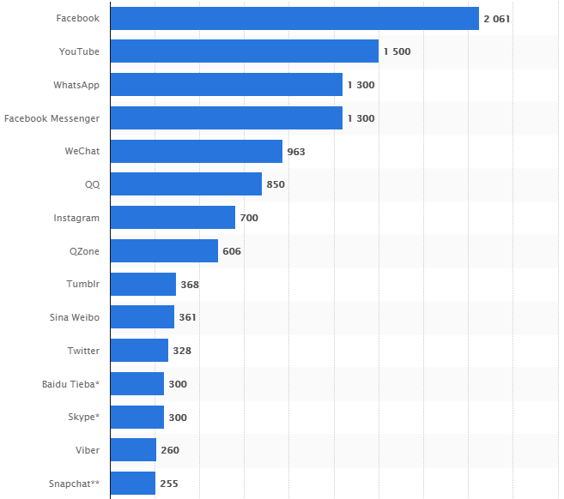

*Figure 1: Top social network sites worldwide as of September 2017,*

*ranked by active users (millions)*

As we can see from Figure 1, Facebook is ranked 1st in term of popularity at 2,061 million active users whereas Instagram is ranked 7th with 700 million active users. YouTube is considered as unsuitable for Haha no Yume because it requires hiring video production experts. YouTube can be considered a platform good for advertising in the case of Haha no Yume but not so good as a bridge to engage and connect with customers, in which Haha no Yume urgently requires to build up their brand names and reputations. WhatsApp, Facebook Messenger, QQ and WeChat is crossed off the list because their main function is messaging. Thus, they are not suitable for building brand awareness and reputation.

Social media platforms with less active users should not be considered as of this stage because Haha no Yume is still a small company, they should not be wasting their resources and efforts aimlessly.

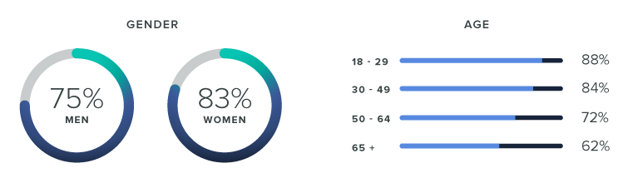

*Figure 2: Facebook’s Demographics*

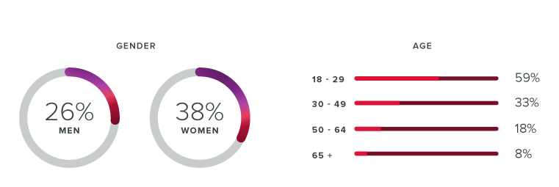

*Figure 3: Instagram’s Demographics*

It is justifiable to choose Facebook and Instagram to run social campaign on. As we can see from Figure 3 and Figure 4, both social media platforms are predominantly female, and it is known that female are more of a shopaholics than men. Also, the age group of both platforms are mostly 18~49 years old. This age group are where most married couple with children are in. Because Haha no Yume specializes in retailing babies and kids clothing, compared to other age group, this age group would be most likely to have interest in the company’s products.

## Strategies

### Create Brand Awareness

In order to create brand awareness, first we need to increase Haha no Yume’s posts exposure. To achieve this, we can use social media platform’s built-in tools such as Facebook’s boosted posts. Boosting a post mean paying the respective social media platform in order to reach more users based on their demographics such as age, gender, location and etc.

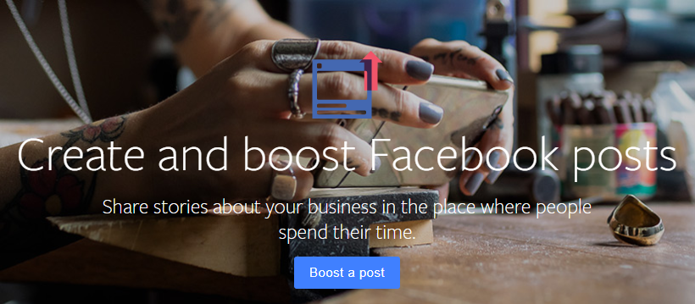

*Figure 5: Facebook’s Post Booster*

### Social Media Influencers

It is a known fact that people always trust peer recommendations more than any company advertisements. Thus, working with a social media influencer will increase the company’s brand awareness and reputation. A brand mention of a social media influencers with loyal followers is way more effective than a post from a company. The followers are most likely to trust the influencer’s opinions, which is why they follow them in the first place. The influencers can also impact the company’s brand SEO (Search Engine Optimization) through brand mentions. The more people are talking about your brand, the likelier they are to share, post, comment or cite in a blog. All of these lead to higher organic traffic.



*Figure 6: How social influencers work*

### Post on specific timing

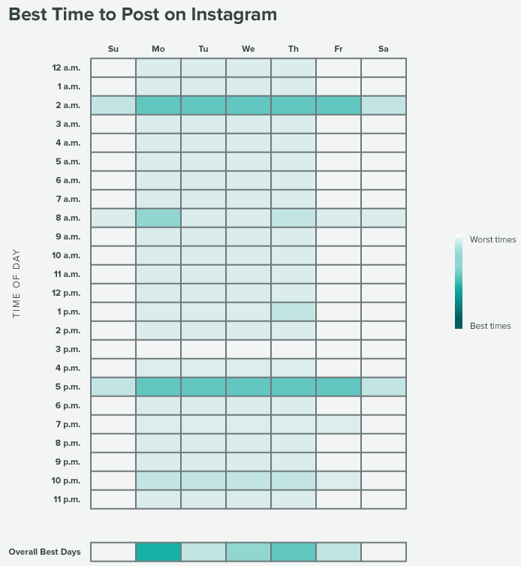

*Figure 7: Correlation chart of Instagram of time against interaction rate*

As we can see from Figure 7, different time on different day have different follower’s interaction rate. For example, 2 a.m. and 5 p.m. during weekdays have a higher interaction rate. Thus, the most recommend posting time would be 2 a.m. and 5 p.m. on Monday through Friday and the worst time to post would be 3 p.m. on any day.

# Haha no Yume’s Current Social Media Campaign

Interacting with customer via comments in Facebook and Instagram to improve relationship with the customers. Creating an image of friendly customer services, thus improving brand reputation.



*Figure 8: Engaging with customer*

Use of hashtags helps in capturing the attention of those who do not follow Haha no Yume yet. 1-2 powerful and relevant hashtags are enough to reach target population. It doesn’t burden the post and helps in garnering new followers. Incorporating hashtags into social media posts also increase the chance of posted content showing up on Google search results.



*Figure 9: Hashtagging posts*

Haha no Yume is using high quality photographs where the photo’s content is suited for their theme. The photo sparks people’s interest and at the same time showcased its product. These types of photos also help in appealing to potential customers who may not have initially been interested in looking at a photo of Haha no Yume’s product.



*Figure 10: A good Instagram photo with Haha no Yume’s product*

Haha no Yume also posts caption which is suited to their theme (Kids & Babies) sometimes. This moves help promote brand image, and engage followers.



*Figure 11: Haha no Yume’s post caption*

Another strategy Haha no Yume used is simply product quality. Product quality is utmost important no matter what. No social media campaign can save a company with poor product quality. If the company’s product quality is poor, negative words will spread and the brand name and reputation will leave bad impression on consumers and potential consumers, thus lowering revenue. On the other hand, if the product quality is great, satisfied customers will leave a good review and spread positive words, thus increasing brand name and reputation.

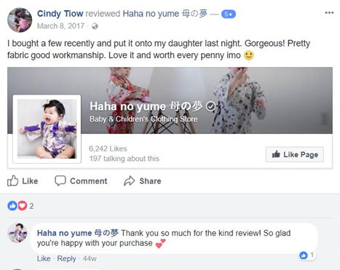

*Figure 12: Satisfied customers leaving good review on Haha no Yume’s Facebook*

# Metrics and their Impacts

## Basic Metrics

* **Number of likes –** Number of people liked the page
* **Number of comments –** Total number of comments on the page
* **Number of reactions –** Similar to likes, but more expressive (haha, sad, wow, love)
* **Page views -** The number of times a Page's profile has been viewed by people
* **Number of shares –** The number of times people shared the post

## Advanced Metrics

* **Keywords wordcloud –** Get the most popular keywords based on users’ comment on the page
* **Sentiment polarity graphs –** Get the polarity (positive, neutral, negative) of the users’ comments

# Dashboard Implementation

There are a lot of metrics which we cannot access directly because we do not have Page Access Token which is only available to the page’s owner/admin.

